
SE-401L Human Computer Interaction Lab
Sir Dr. Hamid Ullah
16 March 2026
Ali Khan – 23MDSWE248
Visit Github
HCI Lab_06
University of Engineering and Technology Mardan
Task #01:
Solution:
Step1: First of all I visited the Fits Law Demonstration website (https://fww.few.vu.nl/chi/interactive/fits/ ) the image is shown below.

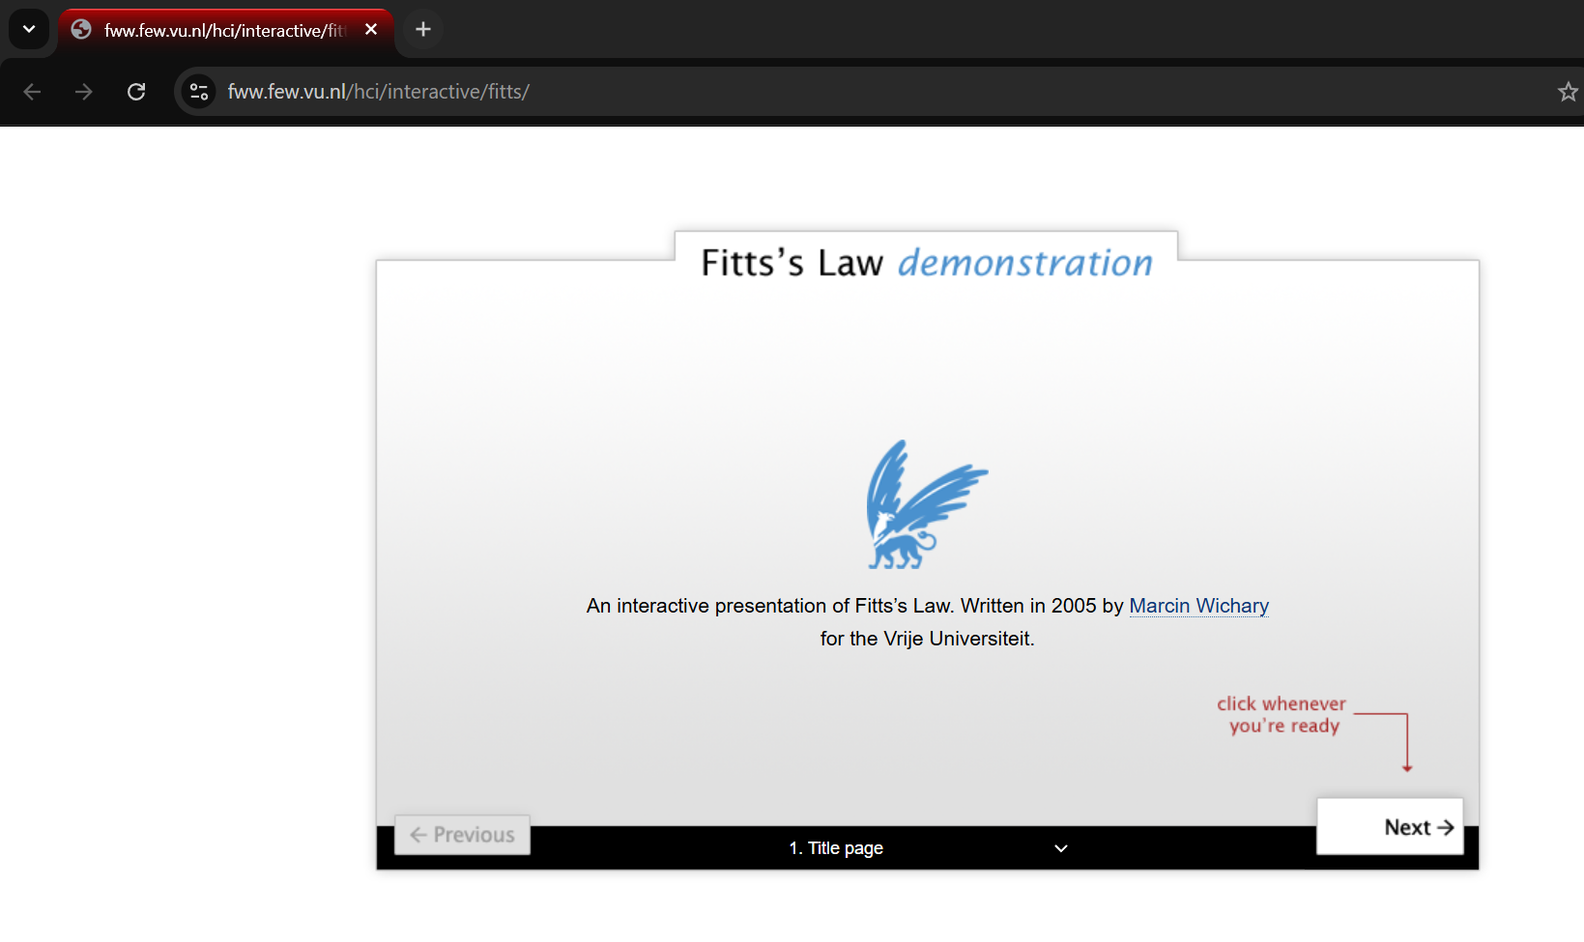
Figure 1

Step 2: I started performing the experiments, each experiment results are shown below

Experiment 1: The experiment was such that all circles (targets) were of the same size and distance
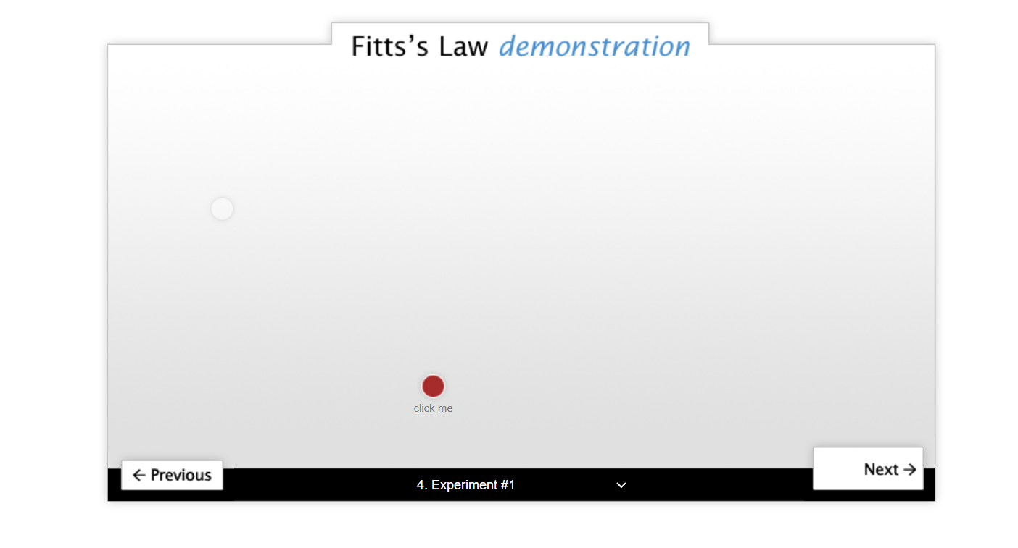

Result: The result shows that the time was almost same
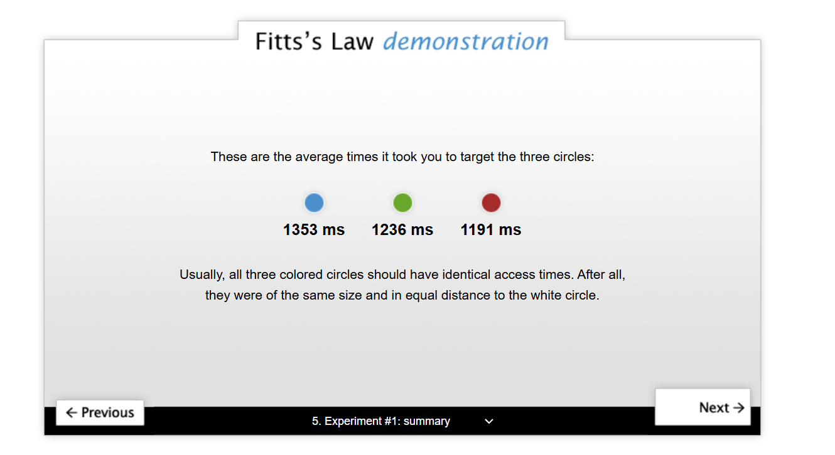

Experiment 2: Based on distance
Result:
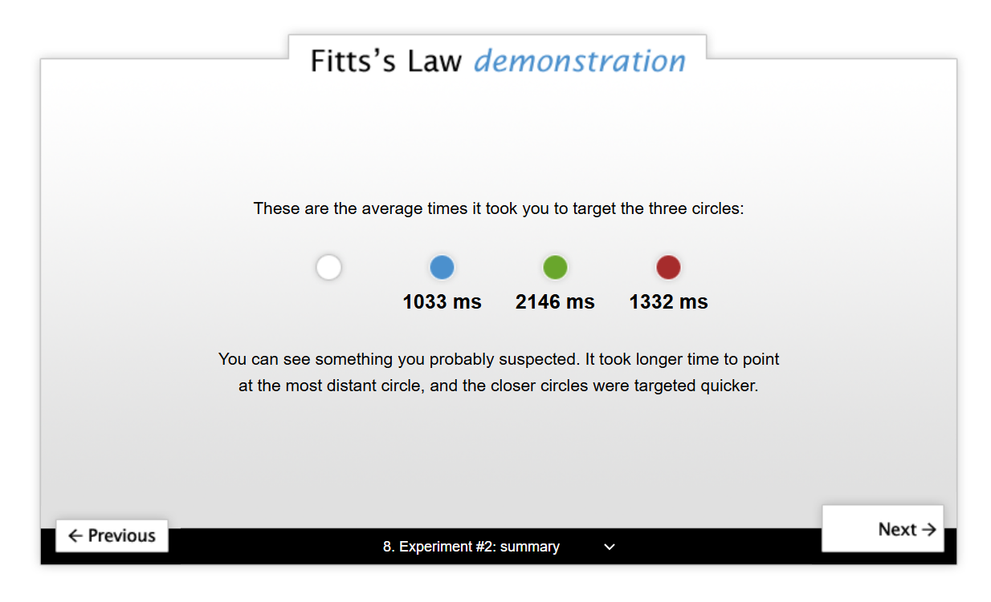
Experiment 3: Based on Size
Result:

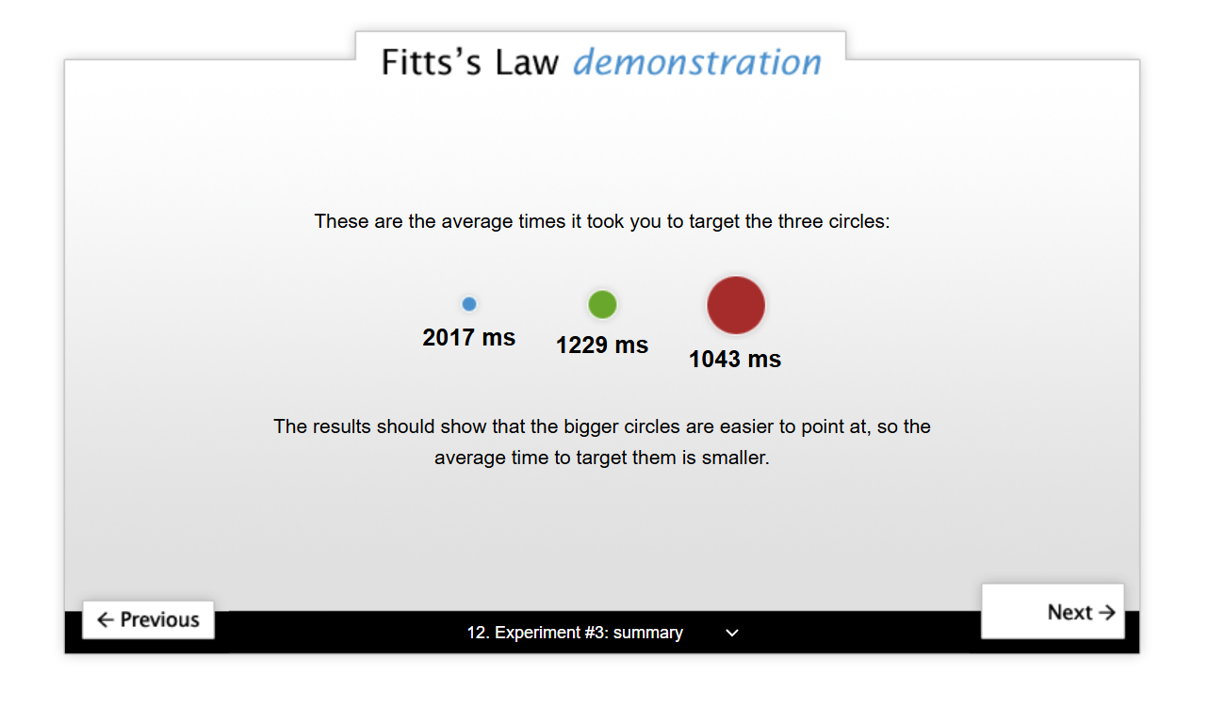

Experiment 4: Based on Size and Distance both
Result:

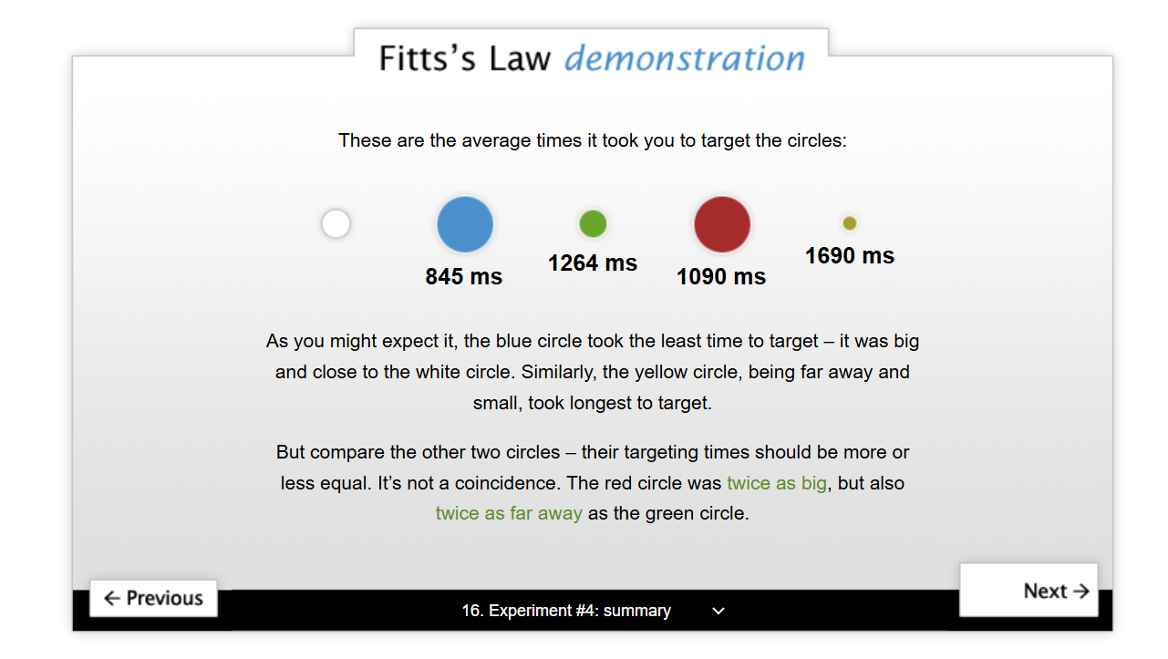

Final Summary:

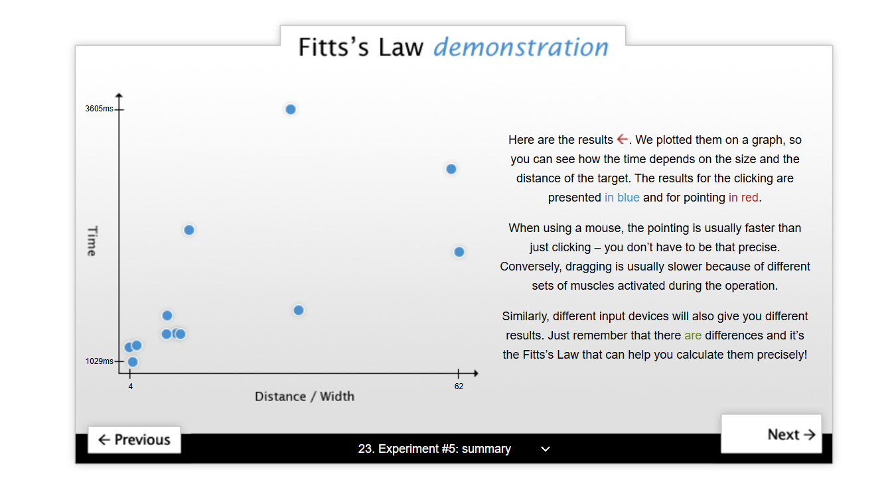

Task #2: PACT Analysis of a Fitness App
Solution:

1. People (Users of the App)
The users of a fitness app can be very different from each other. Some people may be beginners who just want to lose weight, while others may already be fit and want to track advanced workouts.
Users can include:
- Students who want to stay active
- Office workers who sit most of the day
- Athletes who want detailed performance tracking
- Older people who want to maintain basic health
Different users have different needs. For example, beginners may need simple instructions and motivation, while experienced users may want detailed stats and progress charts. Also, some users may not be very technical, so the app should be easy to use.

2. Activities (What users do in the app)
The main purpose of the app is to help users stay fit and healthy. So, users will perform activities like:
- Tracking daily steps, calories, and workouts
- Setting fitness goals (like weight loss or muscle gain)
- Following exercise routines
- Logging meals and checking nutrition
- Getting reminders to exercise or drink water
Some activities are simple (like checking steps), while others require more attention (like entering meal details). The app should make all these tasks easy and quick so users don’t get frustrated.

3. Context (Where and how the app is used)
The app can be used in different situations, such as:
- At home while doing workouts
- In the gym during exercise
- Outside while walking or running
- Even in busy environments like offices
Sometimes users may be in a hurry or distracted, so the app should work smoothly and not require too much focus. Also, the environment can change (like poor internet connection), so the app should still work offline for basic features.

4. Technologies (Tools and systems used)
The fitness app will mainly run on smartphones (Android or iOS). It can also use other technologies like:
- Sensors (step counter, GPS for tracking running distance)
- Wearable devices like smartwatches
- Internet for syncing data and showing updates
- Notifications for reminders and motivation
The app should be optimized so it doesn’t drain battery or slow down the phone. It should also keep user data safe and private.

Conclusion
PACT analysis helps us understand how different users will use the fitness app in real life. By considering people, their activities, the context, and the technology, we can design an app that is easy to use, helpful, and effective in keeping users healthy.

THE END

